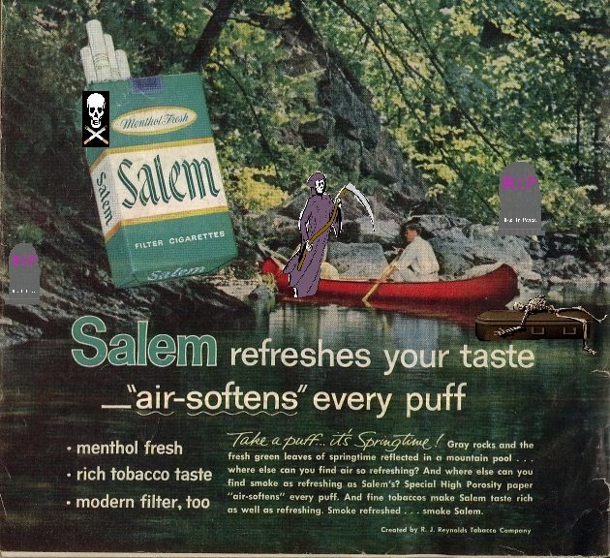
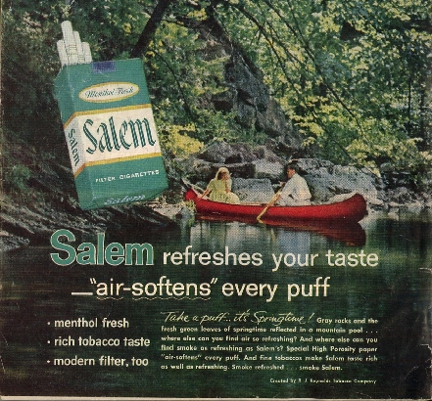

This is an old advertisement from a 1960’s magazine, not that it is much different than ads that are seen today.

BELOW:
This is my re-vamped, edited ad showing a different slant on the message. I’m sure the
point is made.

Original ad:

The original ad above could be considered art, because just about everything is indeed ART, at
least in my opinion. Without the ad copy and cigarette pack, etc…, it would be a very tasteful
photo of a couple enjoying a beautiful and scenic experience in nature. The imagery in the photo
is used to portray the peaceful and harmonious experiences one can have with a loved one, say on
a vacation or day trip to a recreation area. The product being sold is, of course, Salem Ciggies.
The intended consumer for the product being advertised is the general consumer, as I’m sure the
cigarette company was unconcerned as to who specifically might buy this product. I’m sure they
did not care if anyone from any race, age, sex, or gender category bought their product, as long as
they did. The representation of the couple is quite typical for ads of the time and for ads still used
today. The represent a white, middle class, and good-looking youthful couple with the whole world
in front of them to enjoy. This ad reinforces gender roles as they have been typically portrayed and
used in advertising throughout the history of print media advertising in the United States.

Re-done ad:

My revamped and redesigned ad simply is a statement against the very thing that the original ad
is promoting: smoking. Now, regardless of specific brand, a stronger statement is made against the
entire smoking habit. The bodies have changed in that now a grim reaper is seen joining the man on
the boat, appearing only to happy to await his coming early death. The female is removed, hopefully
implying that the only thing you’ll get with smoking is personal horror instead of the attainment of
a beautiful partner. The intended consumer in this new message is the common man, and children,
regardless of age, sex, orientation, gender category, or race. What is now being sold is an idea: that
smoking is bad for your health and may lead to death….which can’t be fun and enjoyable. You will see
a coffin and skeleton floating about in the water and a couple of headstones as well, now making
the peaceful and serene setting into a more foreboding and scary place to be. Even if you recognized
the beauty around the area, it would probably creep you out to see the coffin and headstones, as well
as, that Grim Reaper guy wandering about the area. Though I did not develop my idea further, lacking
time and resources, I think that I at least was able to show how images can be manipulated to convey
new meanings, and that, regardless of gender, sex, race, or age, some messages are universal and can
reach anyone anywhere, even regardless of language. The image alone is enough for someone to get
the idea of what is being presented here. Sometimes shock value is way to get attention, but just like
any other device, it will meet with some approval and some resistance, as not everyone will find it
as a compelling enough image to make a move, to do something, or to buy into the concept.

